**Day 3 – E-Mail Service**

1. Research the following internet protocols related to e-mail services.
   1. SMTP Protocol
   2. POP3 Protocol
   3. IMAP Protocol
   4. Web Mail

Use the following resource as a starting point:  
<https://askleo.com/what_is_pop_or_pop3_or_a_pop_account_and_what_about_smtp/>

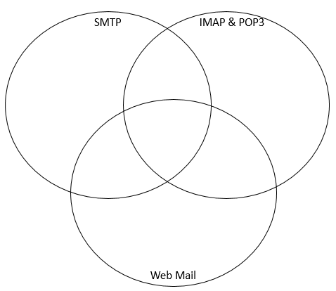Complete the following Venn Diagram to summarize your research.

Emails are accessed from a web browser

Emails are both sent to source from computer.

Application is always running

Safeguards email

Uses desktop program

Both need the name of email provider’s, account ID, etc

SMTP is the protocol used to send emails.

Uses server

Uses Internet

All used for email

The email is displayed from the servers

IMAP and POP3 is used for getting

Your email.